 ISLAMIC UNIVERSITY OF

TECHNOLOGY (IUT)

ORGANIZATION OF ISLAMIC

COOPERATION (OIC)

Gazipur-1704,Dhaka,Bangladesh

Project Title: Bigdeals.com

Presented by:

Aly Abdelkader Gelany 160040021

Abdelkarim Mounkambou 160040022

Supervisor:   
 Faisal Hussain

Lecturer Department of Computer Science and Engineering

(CSE)

Gazipur-1704,Dhaka,Bangladesh

November-2019

**CERTIFICATION**

This is to certify that “**BIGDEALS.COM**” is the outcome of hard work of **Aly Abdelkader Gelany** and **Abdelkarim Mounkambou** as their final year project of Higher diploma in computer science and engineering at the Islamic university of technology (IUT) Dhaka, Bangladesh.

Authors

Aly Abdelkader Gelany Abdelkarim Mounkambou

Student ID: 160040021 Student ID: 160040021

Date:

Supervisor Head of Department

Name: Mr. Faisal Hussain Name: Pro. Muhammad Muhbob Alam

Signature: Signature:

Date: Date:

Department of Computer Science and Engineering (CSE)

Islamic University Of Technology (IUT)

**ACKNOWLEDGEMENT**

All praises to Allah for the strength and blessings he accorded to us in completing this project. Special appreciation goes to our supervisor, Mr. Faisal Hussain, for his supervision and constant support.

We would like to convey our deep gratitude and appreciation to our friends and family members who supported us morally, financially, by prayer or by providing us constant feedback which helped towards the successful completion of our project.

Abstract

Internet has become one of the most used channels for marketing and advertising as by 2019 The estimated population connected on internet in Africa is about 492.7 million. And particularly 6,13 million in Cameroon with 25,876,380 million inhabitants. Based on these facts we intended to provide a web platform on which advertisers in Cameroon can post and monitor advertisements from used to new items or services. Customers can browse and purchase some products or engage in communication with sellers.

We used a model view controller (MVC) architecture and various web technologies such as html, CSS and JavaScript for front-end, and php for back-end using Laravel framework. The implementation based on business to business and consumers to consumers approach aims to provide a free advertising tool that emphasize on time saving, transparency and consumers satisfaction. The use of this platform can make significant contribution in helping, business to engage, and convert virtual visitors to customers.

**DEDICATION**

This project is wholeheartedly dedicated to our beloved parents, who have spared no effort to ensure our success, and have been continually providing us their moral, spiritual and financial support.

Contents

Chapter 1 – Introduction 1

1.1 Overview 1

1.2 Problem Definition 1

1.3 Motivation 2

1.4 Issues 2

1.5 Objectives 2

1.6 Requirements 3

Chapter 2- Diagram 4

2-1 Architectural Diagram 4

2-1-1 The Model 4

2-1-2 The Controller 4

2-1-3 The View 4

2-2 Modeling Diagram 5

2-2-1 Context Diagram 5

2-2-2 Diagram Zero 6

2-2-3 Diagram-1 8

2-2-4 Activity Diagram for A User Purchasing an Item 9

2-2-5 Entity Relationship Diagram (ER) 10

Chapter 3 -Features 11

3-1 Admin Features 11

3-2 Sellers’ Features 11

3-3 Guest Features 11

3-4 Authenticated Users ‘Features 12

3-5 VIP Badge 12

3-6 Payment Method 12

Chapter 4- Technologies and Tools 13

4-1 Programming Languages 13

4-2 Scripting Languages 13

4-3 Libraries 13

4-4 Framework 13

4-5 API (application program interface) 13

4-6 Web Server 13

4-7 Database Server 13

Chapter 5- User Interface Design 14

5-1 Admin Panel 14

5-1-1 Admin Dashboard 14

5-1-2 Users Management 15

5-1-3 Catalogue Management 16

5-1-4 Location Management 17

5-1-4 Advertisement Management 18

5-1-4 Orders Management 19

5-1-4 Feedback Management 19

5-2 Users’ Interface 20

5-2-1 Login Interface 20

5-2-2 Register Interface 20

5-2-3 Home Page 21

5-2-4 Products List Page 22

5-2-5 Products Details Page 23

5-2-6 Users Dashboard 24

5-2-7 User Posted Ads Management 24

5-2-8 User List of Favorite Ads 25

5-2-9 User Edit Profile 26

5-2-10 User Order 27

5-2-11 My Chat 27

Chapter 6- Conclusion and features work 28

6-1 Future Work 28

6-2 Conclusion 28

Table of Figures

Figure 1 Architectural Diagram 4

Figure 2: Context Diagram 5

Figure 3: Diagram Zero 6

Figure 4: Diagram 1 8

Figure 5: ER Diagram 10

Figure 6: Admin dashboard 14

Figure 7: User management 15

Figure 8: Catalogue management 16

Figure 9: Location management 17

Figure 10: List of advertisements 18

Figure 11: admin updating ads info 18

Figure 12: Orders management 19

Figure 13: Feedback management 19

Figure 14: Login interface 20

Figure 15: Register interface 20

Figure 16 :Home page 21

Figure 17: product list 22

Figure 18 :product details page 23

Figure 19: Users Dashboard 24

Figure 20: manage ads for users 24

Figure 21: User list of favorite ads 25

Figure 22: User Edit Profile 26

Figure 23 : users orders list 27

Figure 24: My chat 27

# Chapter 1 – Introduction

## 1.1 Overview

Digital marketing is the processes of creating, communicating, delivering offerings that have value for consumers such as products or services using digitals channels such as web-channel to spread a message about a company’s brand, products, or services. The objective of marketing is to reach potential customers through the channels where they spend their time reading, searching, shopping, and socializing online. Bigdeals.com is a digital marketing tool where we can buy and sell almost everything from used items to new items or services. Users can sign up for free and post advertisement easily or browse through a large category of items and services Offred in their regions or cities. We used a Transaction based revenue/fee through our VIP advertisements.

In the following lines we tried to explain the architectures, various components, and various features of this system.

## 1.2 Problem Definition

While traditional marketing is still in used, it involves important drawbacks and limitations that is to be considered buy marketers.

These limitations range from Little Interaction, Poor Campaign Measurement, No Control Over Timing, and Higher Costs since the recurring costs in traditional marketing can prove to be a huge investment that may or may not give a good return. And Consumers are trapped by geographical and social boundaries, unable to search widely for the best price and quality Information about products.

The problem is to build a cost-effective and interactive platform Giving opportunity to customers to browse according to their cities, regions or through a wide range of categories from the comfort of their home. And also give opportunity to advertisers to post and monitor their advertisements.

## 1.3 Motivation

* provide a cost-effective tool for advertisement as users can post advertisements for free
* Develop a platform that bring buyers and sellers closer

## 1.4 Issues

* Finding the right advertisement or products is time consuming and a tedious task for customers
* The costs in traditional marketing can prove to be a huge investment
* The traditional advertisement requires customers to move to the shop before to buy the advertised product or service
* With traditional marketing there is no real control since it depends on methods that, once executed cannot be updated. Whether it is a static text print ad in a local newspaper or a television commercial, we will need to place a new ad to replace the old one in case of any change
* there is little or no interaction between the customers and the medium used for marketing. Buyers need to move to sellers stores before to discuss about the price or quality of products

## 1.5 Objectives

* Provide a user-friendly interface for customers to browse through categories and sub-categories according to their regions or cities
* Provide an interface for sellers to post and monitors their advertisements for free
* Provide purchase facilities to customers through VIP products
* Provide an interface for the administrator to monitor and manage the activities of the system
* Provide a chatting system for sellers and buyers to engage in real time communication for negotiation.

## 1.6 Requirements

* The system should be user friendly and intuitive such that it can be understood and used by non-technical persons
* Users should have full control on their account and advertisements
* The system should be responsive
* The system should be secured and protect against attacks such as cross site request forgery and SQL injection

# Chapter 2- Diagram

## 2-1 Architectural Diagram

The system is based on Model view controller.

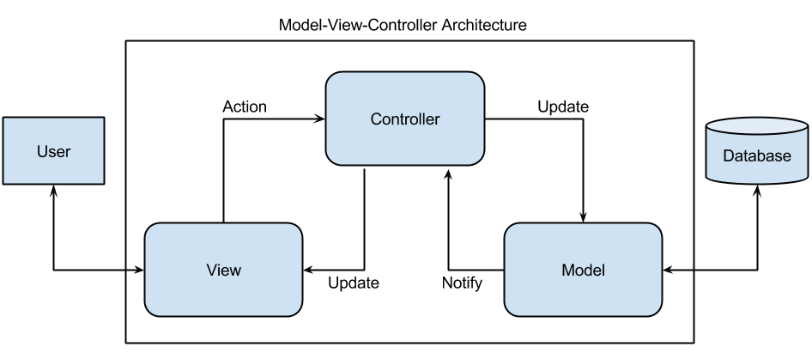

Figure 1 Architectural Diagram

### 2-1-1 The Model

Implemented using php, it interacts with all the system related data and entities. It connects to the database to provide data to the controller and the view.

### 2-1-2 The Controller

Implemented using php it represents all the business logic of the system and act as an intermediary between the model and the view.

### 2-1-3 The View

Implemented using HTML, CSS and JavaScript it is responsible for presentation and formatting of data sent to and from the controller or the model.

## 2-2 Modeling Diagram

### 2-2-1 Context Diagram

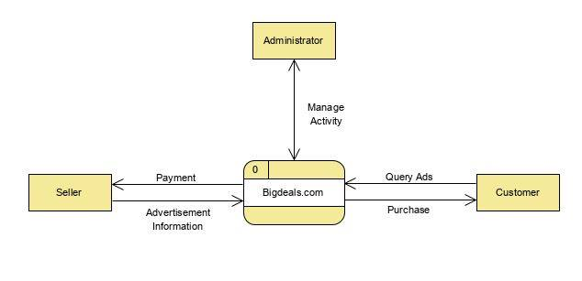

Figure 2: Context Diagram

Description:

The context diagram contains:

* The main process which is the system name (Bigdeals.com)
* And three entities:
* Sellers who post advertisements
* Customer who browse and purchase advertisement products
* Administrator who monitor and manage the activity of the system

### 2-2-2 Diagram Zero

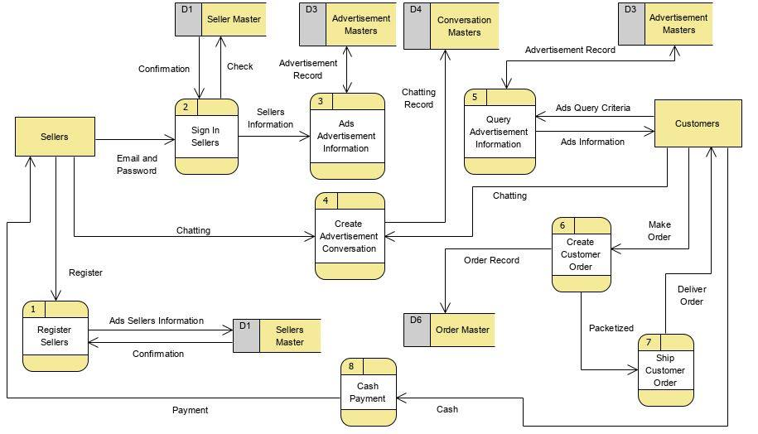

Figure 3: Diagram Zero

Description:

The diagram 0 is the expansion of the context diagram showing main process of the system:

* Eight (8) process:
* 1-Register seller system
* 2-sign in sellers
* 3-ad advertisements information
* 4-create advertisement conversation
* 5-query advertisement information
* 6-create customer orders
* 7-ship customer orders
* 8-cash payment
* Five (5) data store
* D1-seller master
* D3-advertisement master
* D4-conversation master
* D6-order master
* Two (2) entities
* Sellers
* customers

### 2-2-3 Diagram-1

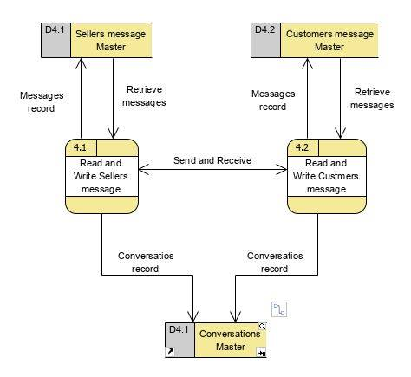

Figure 4: Diagram 1

Description:

The diagram 1 is the expansion of the process 4(create advertisement conversation) from the diagram 0. it contains:

* two (2) process:
* read and write sellers message
* read and write customers message
* three (3) datastores
* sellers message master
* customers message master

### 2-2-4 Activity Diagram for A User Purchasing an Item

In this diagram we show the flow of data when a user login into the system and purchase an item.

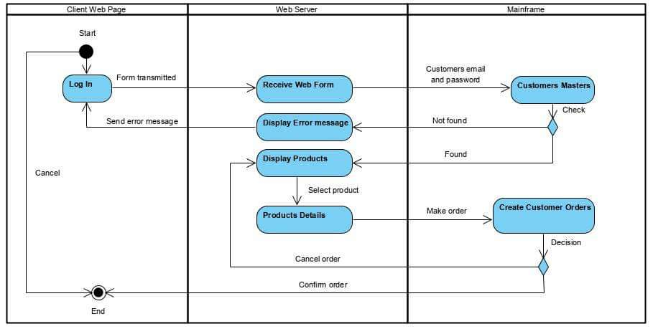

### 2-2-5 Entity Relationship Diagram (ER)

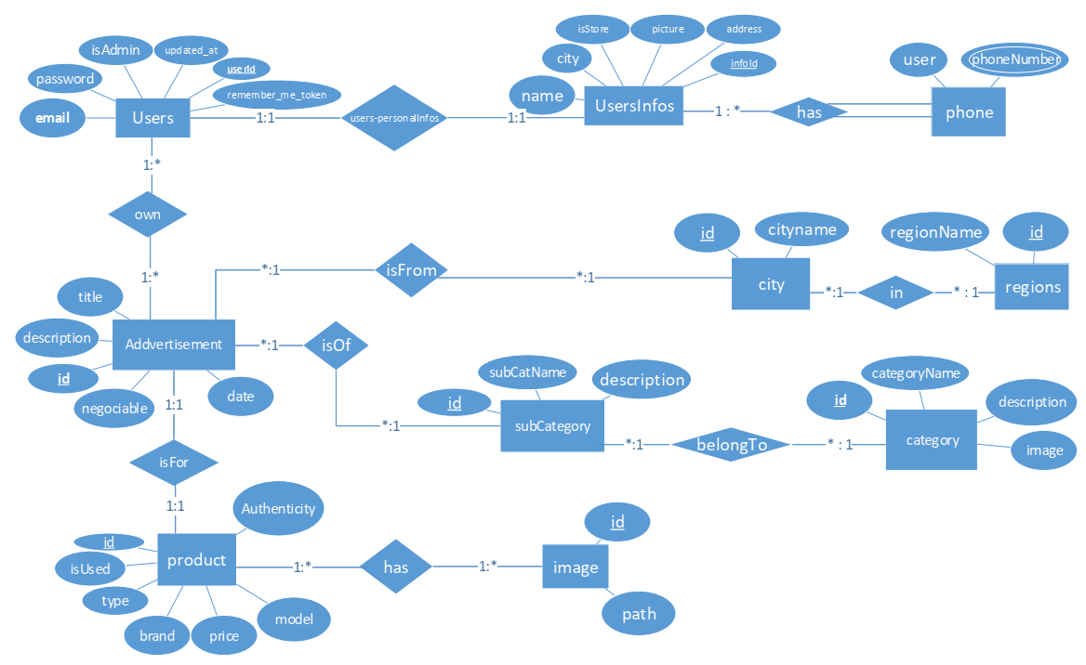

Figure 5: ER Diagram

Chapter 3 -Features

3-1 Admin Features

The administrator of the system can:

* Add and manage categories and subcategories
* Add and manage regions and cities
* Validate and block advertisements
* Block and unblock users
* Manage orders
* Respond to VIP request
* Respond to users’ feedback

3-2 Sellers’ Features

A person who wants to sell or advertise a product can:

* Login or register
* Post unlimited ads for free
* Edit his advertisement
* View his advertisement
* Delete his advertisement
* Request for VIP badge
* Chat with potential buyers
* Edit his personal information

3-3 Guest Features

A guest on the system can:

* Browse advertisements according to regions or cities
* Browse advertisement by categories or subcategories
* Browse advertisement by providing keywords
* Filter advertisement by price
* Filter advertisement by condition of the advertised product (used items or new)
* Filter advertisement by pricing (fixed price or negotiable price)
* Filter advertisement by VIP status of the product
* Filter advertisement by price (min and max price)

3-4 Authenticated Users ‘Features

An authenticated user can do all of the above-mentioned features and also can:

* Place an order for VIP products
* Cancel his order
* Engage in real time communication with sellers
* Save advertisement as favorite
* Rate sellers

3-5 VIP Badge

VIP badge is a feature implemented in order to monetize our system by facilitating transaction between buyers and sellers. A seller after posting his product advertisement can request for VIP badge. Once the administrator verifies the conformity of his advertisement, he can approve his request and notify the sellers that his request was accepted. After the request is accepted our logistic service will collect the seller’s product. once the Sellers’s product Is collected his advertisement will now be display as a VIP advertisement, and customer will be able to purchase it online. once a VIP product is ordered by a customer, the delivery is made by our service and we take 5% of the selling price and return 95% to the sellers.

3-6 Payment Method

For VIP product we perform cash on delivery meaning a customer pays when he receives the product.

# Chapter 4- Technologies and Tools

## 4-1 Programming Languages

Php 7.3.2 use to represent business logic.

## 4-2 Scripting Languages

Html 5, CSS3 and JavaScript used in front-end development to represent views.

## 4-3 Libraries

* Bootstrap 4.3.1 as CSS library
* jQuery 3.3.1 as JavaScript library
* Jsmap: a JavaScript library used to draw Cameroon map

## 4-4 Framework

* Laravel 5.8:

Laravel is a server-side PHP framework using the model view controller (MVC) architecture.

## 4-5 API (application program interface)

* Pusher: used to broadcast message event in case of our real time chatting feature.
* Addthis.com: use for social sharing

## 4-6 Web Server

* Xampp 7.3.2

## 4-7 Database Server

* MySQL (10.1.38-MariaDB)

# Chapter 5- User Interface Design

## 5-1 Admin Panel

### 5-1-1 Admin Dashboard

In the administrator dashboard we display a statistic overview about the main entities of the system starting from numbers of users to numbers of advertisements, number of VIP request, numbers of orders, cities, regions and others.

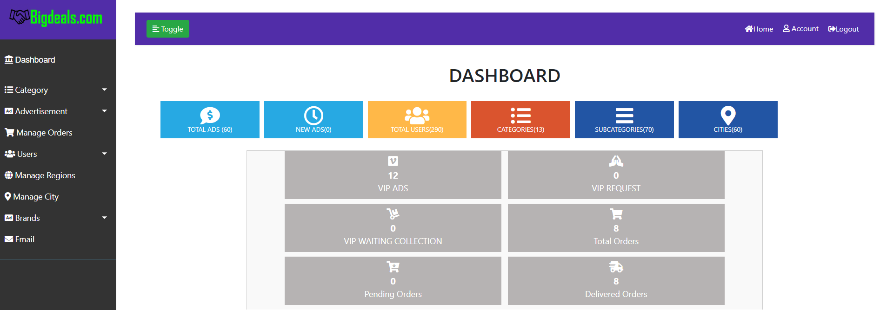

Figure 6: Admin dashboard

### 5-1-2 Users Management

Admin can manage users by viewing the list of all users or by blocking or unblocking them.

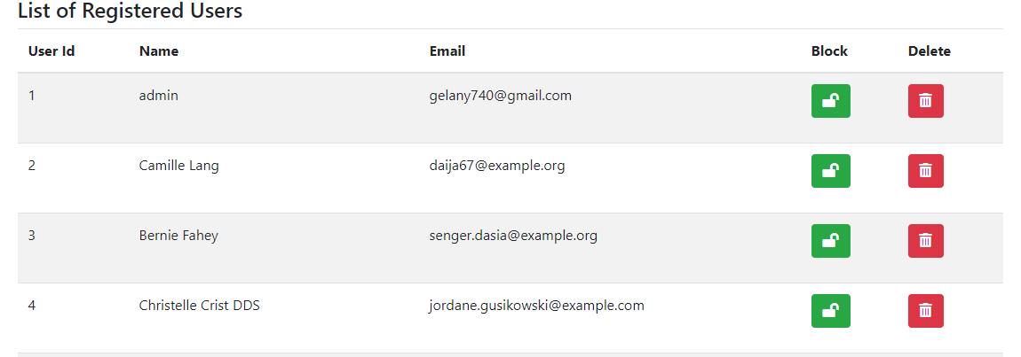

Figure 7: User management

### 5-1-3 Catalogue Management

Admin can manage categories and sub categories by editing existing one or adding new one.

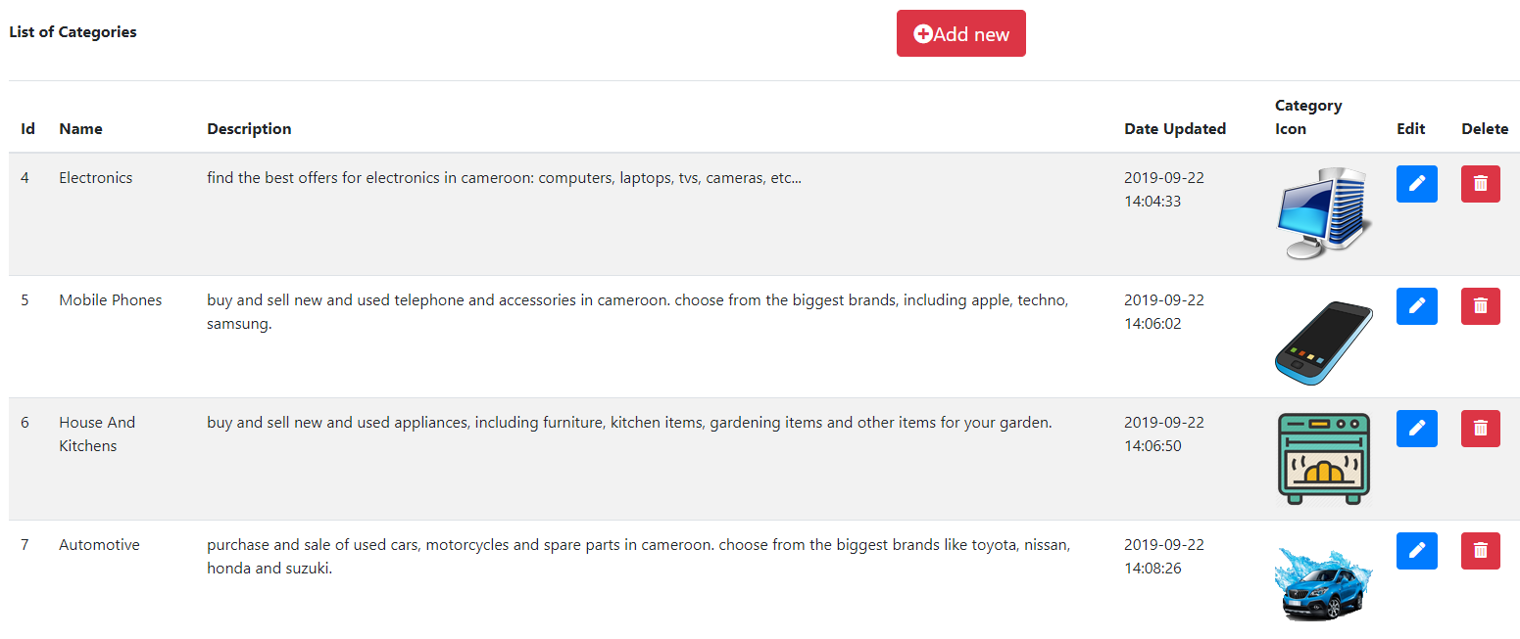

Figure 8: Catalogue management

### 5-1-4 Location Management

Admin can manage regions and cities by editing existing one or adding new one.

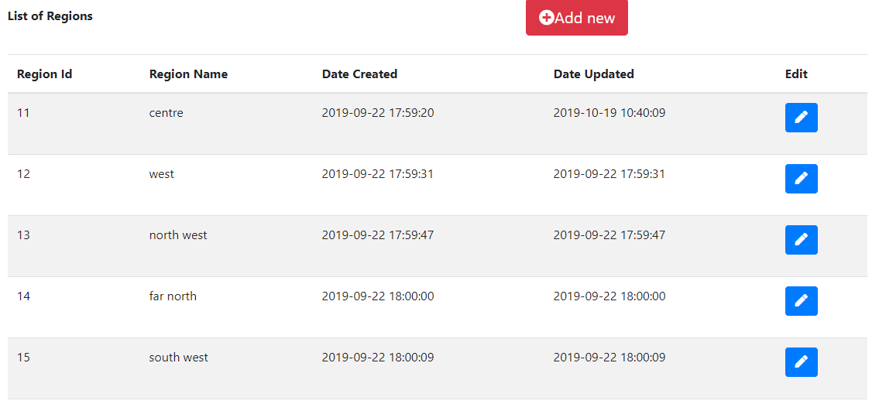

Figure 9: Location management

### 5-1-4 Advertisement Management

Admin can manage advertisements by verifying, validating, blocking or responds to VIP request badge.

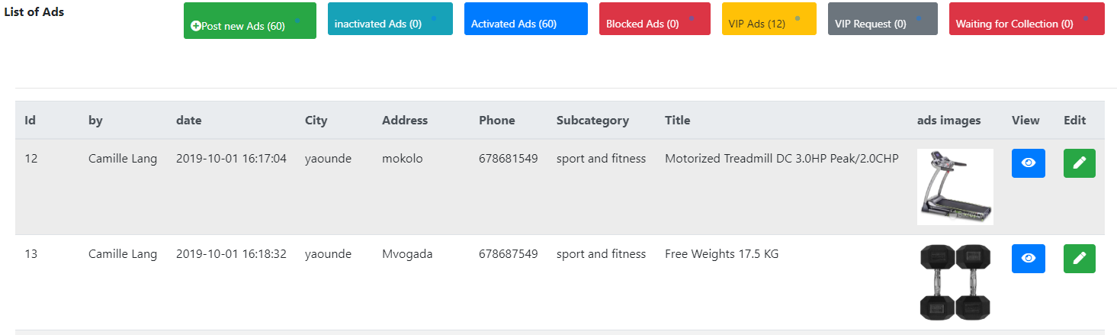

Figure 10: List of advertisements

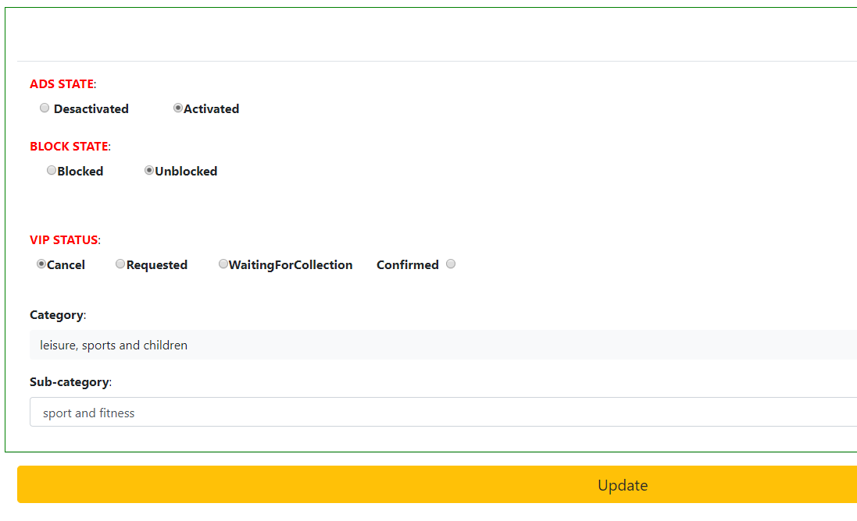

Figure 11: admin updating ads info

### 5-1-4 Orders Management

Admin can manage orders by viewing orders details, or changing the order status to delivered, pending or cancel.

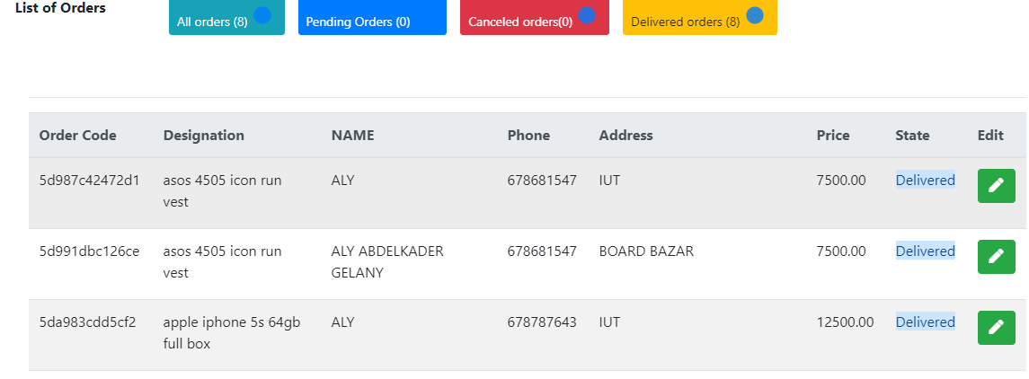

Figure 12: Orders management

### 5-1-4 Feedback Management

Admin can respond to feedback by directly replying to users’ messages.

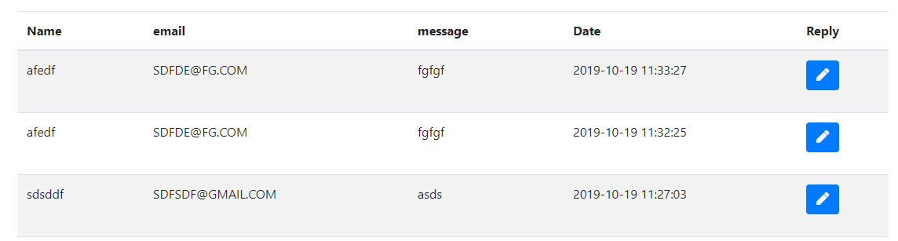

Figure 13: Feedback management

## 5-2 Users’ Interface

### 5-2-1 Login Interface

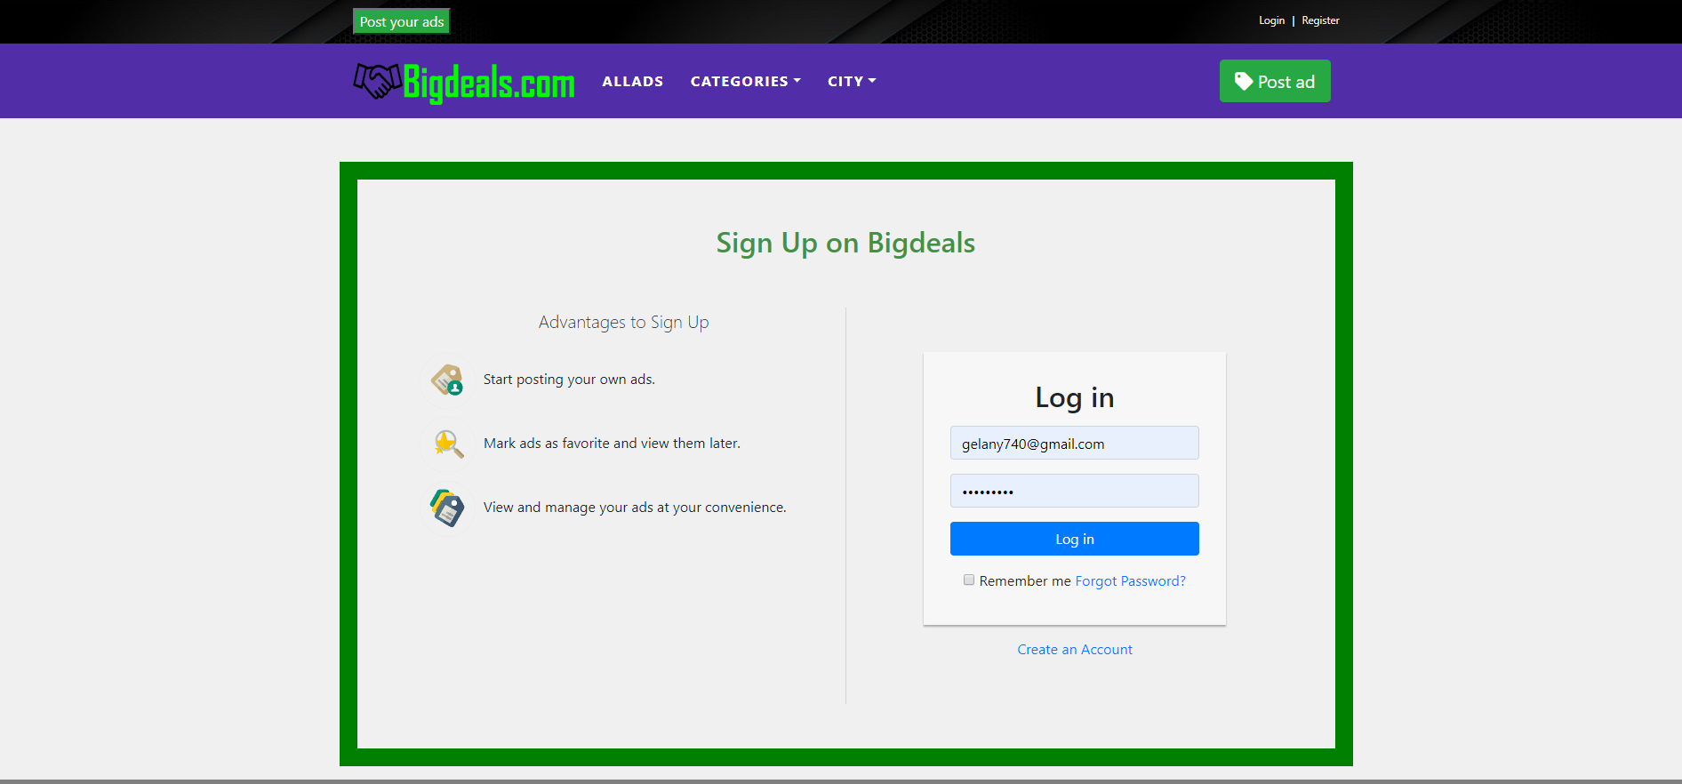

Figure 14: Login interface

### 5-2-2 Register Interface

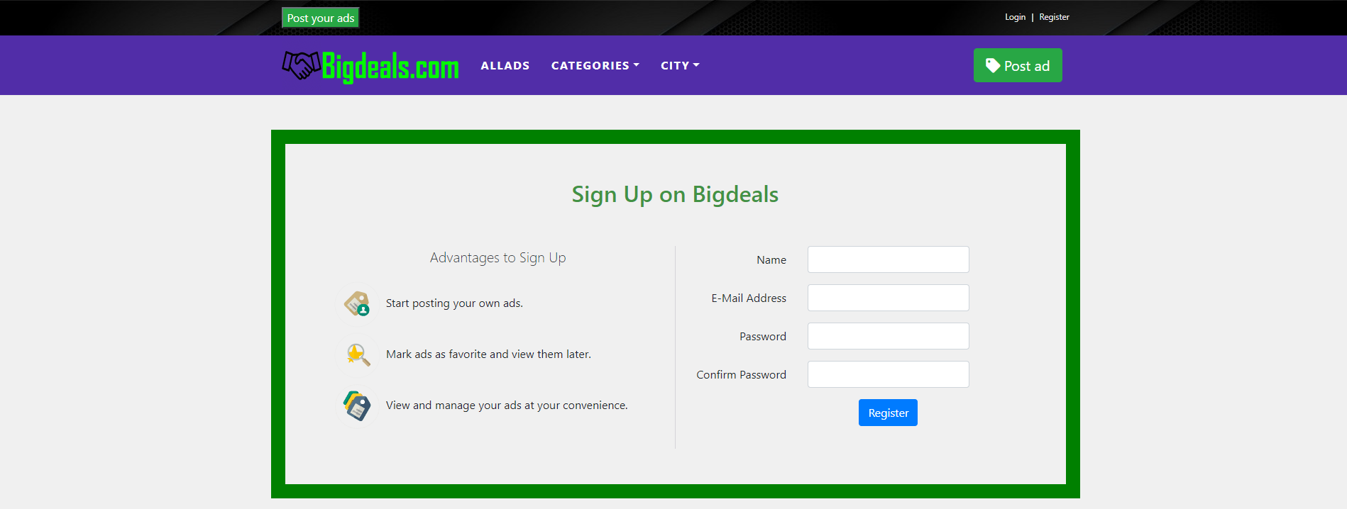

Figure 15: Register interface

### 5-2-3 Home Page

From home page a user can browse directly by region by selecting a desired region from the map or browse by categories by selecting our main categories.

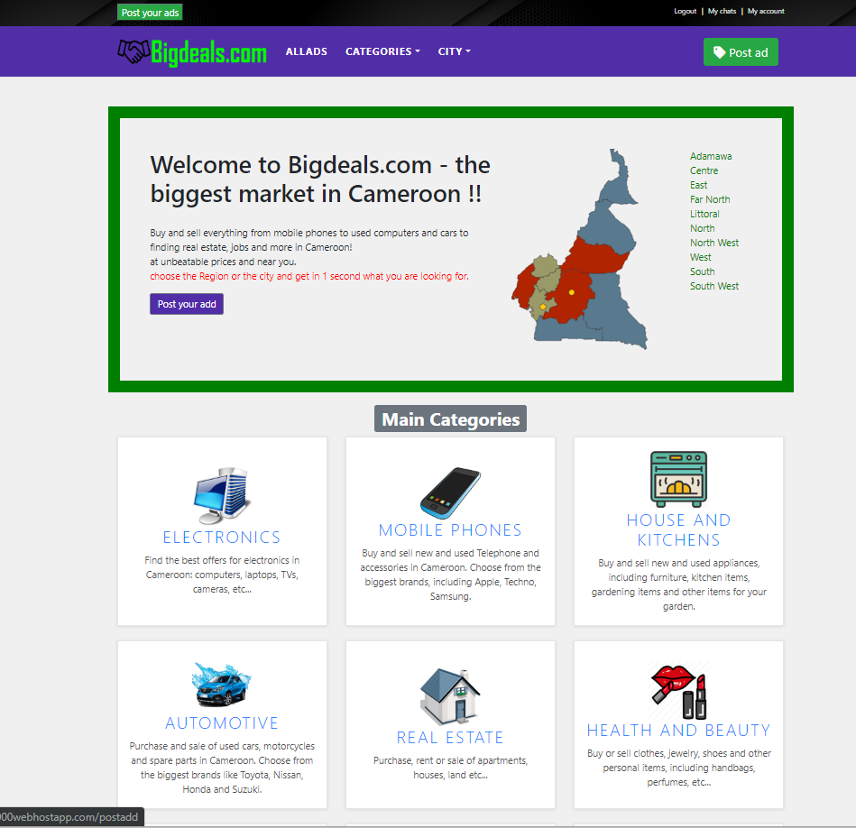

Figure 16 :Home page

### 5-2-4 Products List Page

Here we display a list of advertisements products with short details giving the possibility to the user to filter the list according to price, condition or VIP status of advertisements.

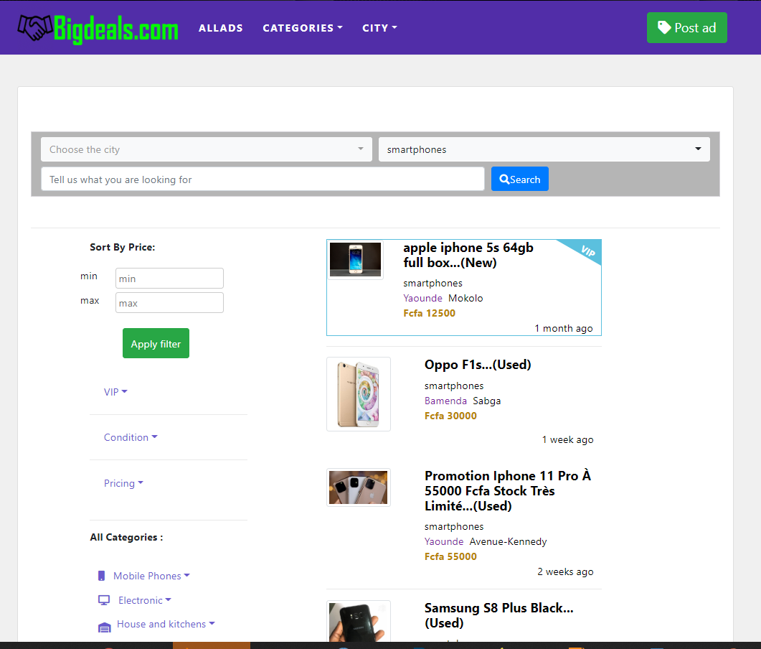

Figure 17: product list

### 5-2-5 Products Details Page

On this page we display various information’s concerning the product advertisement, giving possibility to users to purchase the product, to save the advertisement as favorite, to chat with the seller or to rate the seller based on purchased experience.

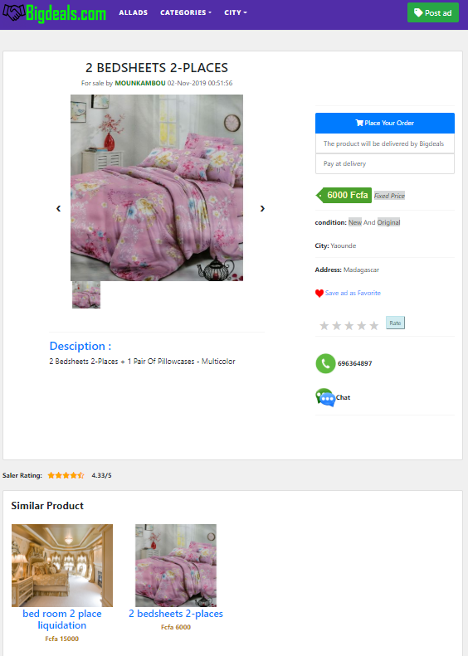

Figure 18 :product details page

### 5-2-6 Users Dashboard

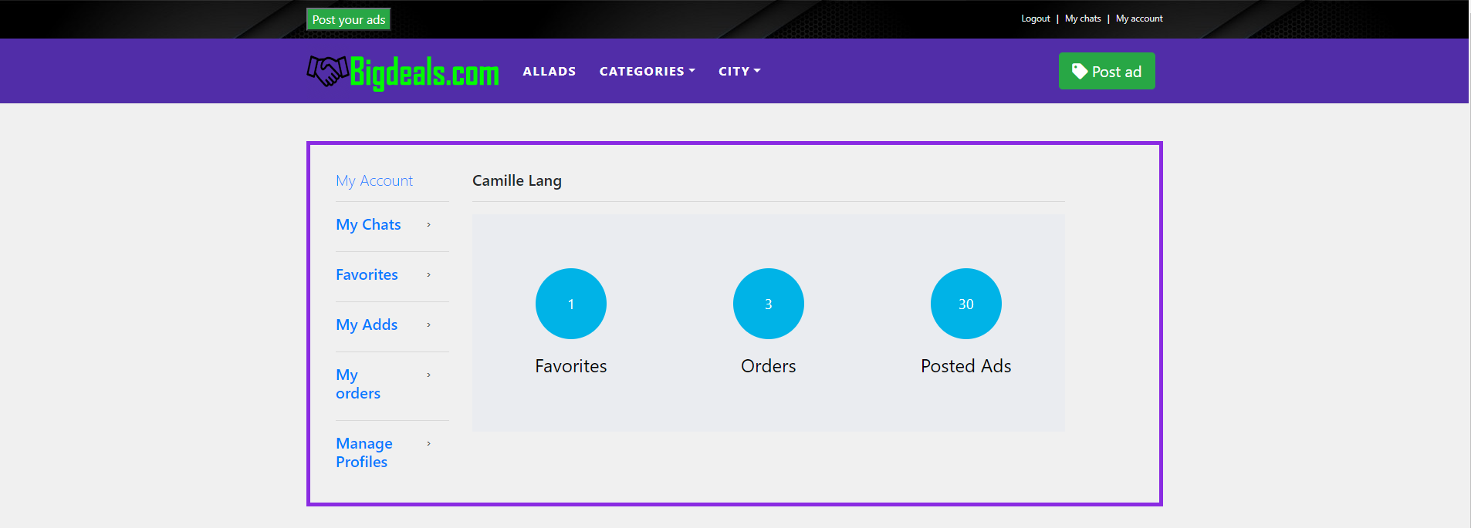

Figure 19: Users Dashboard

### 5-2-7 User Posted Ads Management

Here we give possibility to users to view the list of their ads, edit, delete or request for VIP badge.

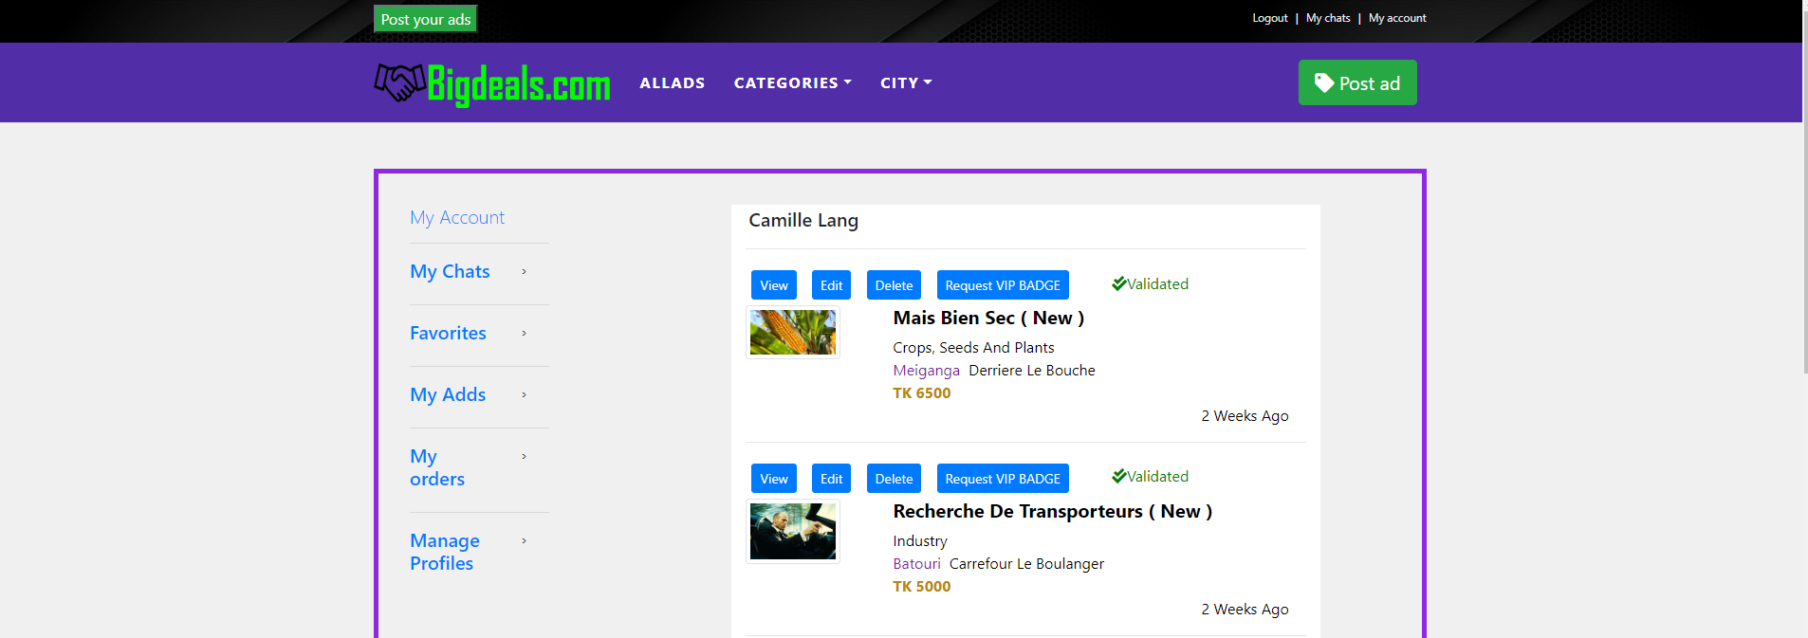

Figure 20: manage ads for users

### 5-2-8 User List of Favorite Ads

A user can display the list of his favorite ads or delete them.

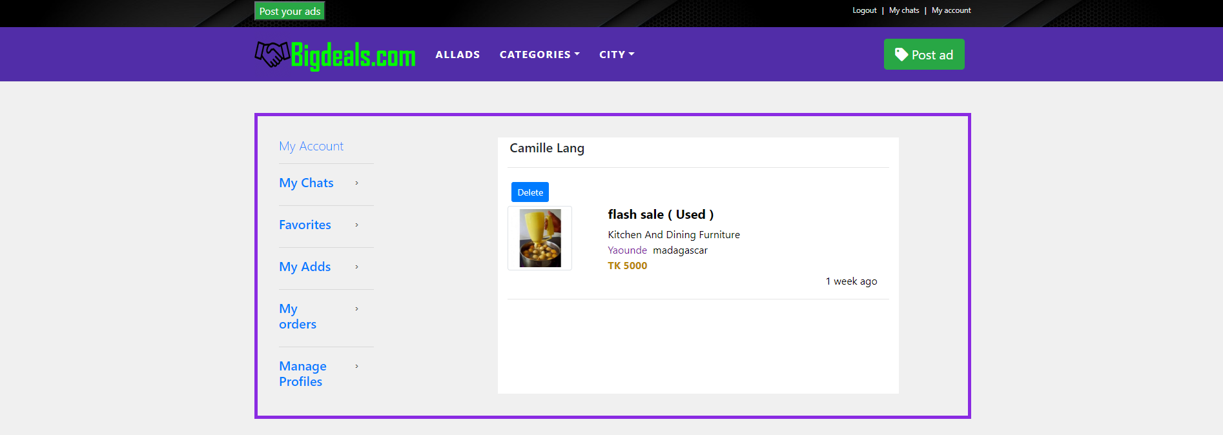

Figure 21: User list of favorite ads

### 5-2-9 User Edit Profile

A user can optionally update hi personal information or change his password

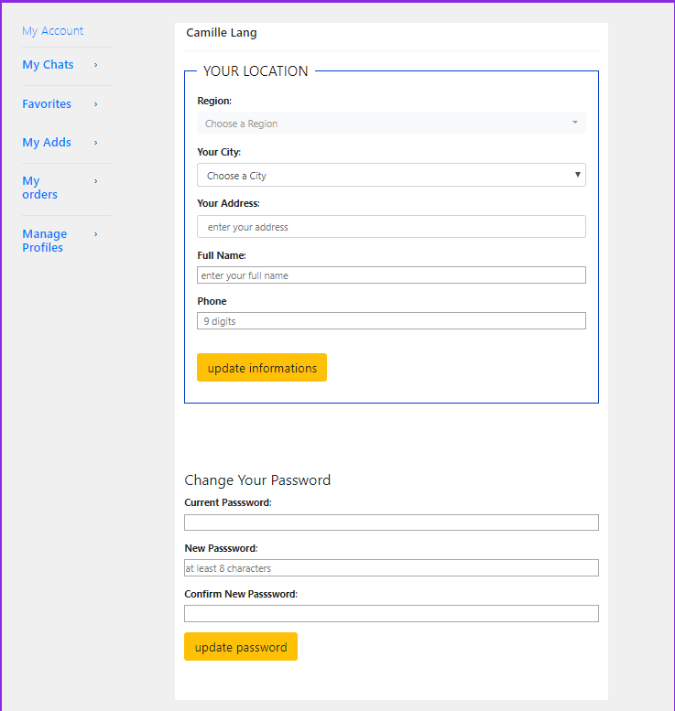

Figure 22: User Edit Profile

### 5-2-10 User Order

Display the list or users purchased items and give him possibility to cancel pending

Orders.

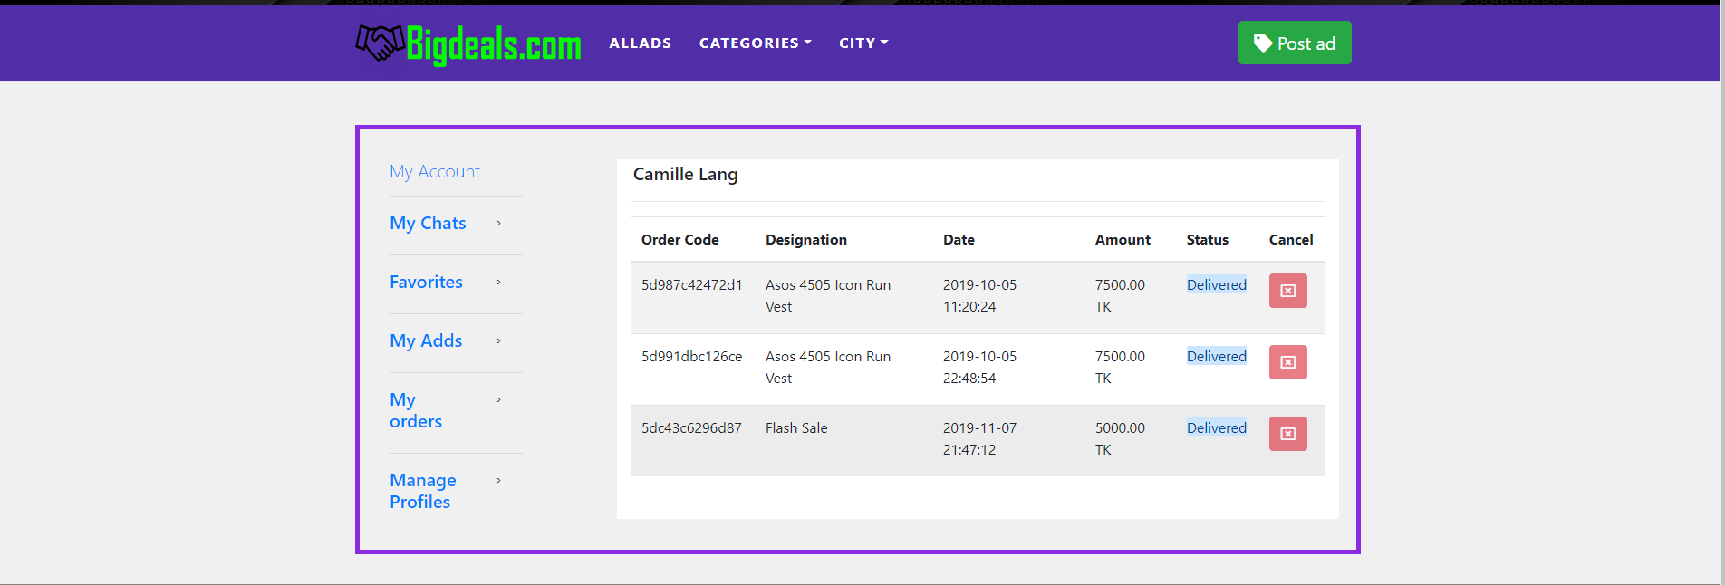

Figure 23 : users orders list

### 5-2-11 My Chat

In this interface a user can read and manage his messages.

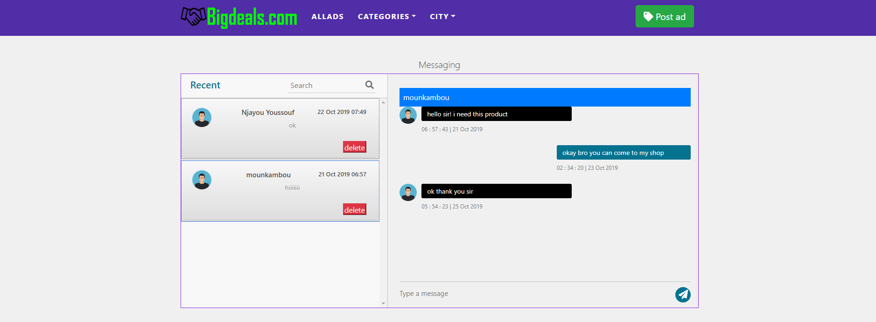

Figure 24: My chat

# Chapter 6- Conclusion and features work

## 6-1 Future Work

In the future we will like to include an online payment system and more features for monetizing our system.

## 6-2 Conclusion

The Internet has become a major resource in modern business, marketing and communication. Using this system can increase business gain, attract more customers and improve the visibility of a business.